## **A REAL TIME RESEARCH PROJECT REPORT**

**ON**

# **“STUDENT PROGRESS TRACKER”**

*Submitted in partial fulfillment of the requirements for the award of degree of*



### **BACHELOR OF TECHNOLOGY**

**In**

### **INFORMATION TECHNOLOGY**

**By**

|  |  |
| --- | --- |
| **MD. NABIHA**  **Y. VANI**  **B. VARUN**  **M.RAMKUMAR** | **22J41A1239**  **22J41A1265**  **22J41A1208**  **22J41A1233** |

Under the Guidance of

**Ms. B. Pragathi**

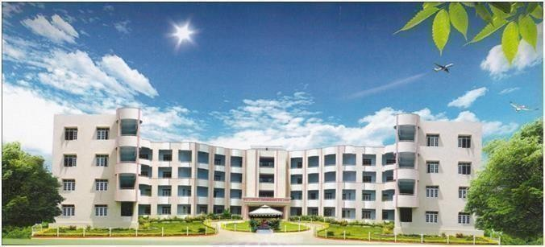 **Assistant Professor**

# **DEPARTMENT OF INFORMATION TECHNOLOGY**

|  |  |
| --- | --- |
|  | **Malla Reddy Engineering College**  (UGC Autonomous Institution, Approved by AICTE, New Delhi & Affiliated to JNTUH, Hyderabad).  rd  Accredited 3rd time by NAAC with ‘A++’ Grade, Maisammaguda (H), Medchal-Malkajgiri District, Secunderabad, Telangana State – 500100, [www.mrec.ac.in](http://www.mrec.ac.in/) |

i

**MALLA REDDY ENGINEERING COLLEGE**

**(AUTONOMOUS)**

**Maisammaguda, Dhulapally (Post Via Kompally), Secunderabad – 500100 Telangana**

**DEPARTMENT OF INFORMATION TECHNOLOGY**



**BONAFIED CERTIFICATE**

This is to certify that the project work titled “**STUDENT PROGRESS TRACKER**” is a bonafide work done by **MD. NABHIHA (22J41A1239), Y. VANI (22J41A1265), B. VARUN (22J41A1208), M. RAM KUMAR (22J41A1233)** in the partial fulfillment of **Bachelor of Technology** in **Information Technology** of **Malla Reddy Engineering College (Autonomous)** affiliated to JNTUH, Hyderabad and that this has not submitted for the award of any other degree of any Institution/University.

**Ms. B.pragathi Dr.Deena Babu Mandru**

Assistant professor Professor and HOD

Department of IT Department of IT

Malla Reddy Engineering college Malla Reddy Engineering college

Secunderabad,500100 Secunderabad,500100

Internal Examiner External Examiner

**Submitted for Real Time Research Project Viva-voice Examination held on _______________**

ii

# **DECLARATION**

We hereby declare that this project work dissertation titled ““**STUDENT PROGRESS TRACKER**”**”** is original and bonafide work of our own in the partial fulfillment of the requirements for the award of the degree of **Bachelor of Technology** in **Information Technology** at **Malla Reddy Engineering College (Autonomous)**, affiliated to **JNTUH*,* Hyderabad** under the guidance of **Ms.B. Pragathi**, **Assistant Professor,** Department of Information Technology and has not been copied from any earlier reports.

**STUDENTNAME ROLLONO SIGNATURE**

MD.NABIHA 22J41A1239

Y.VANI 22J41A1265

B.VARUN SAI 22J41A1208

M.RAMKUMAR 22J41A1233

iii

# **ACKNOWLEDGEMENT**

We are extremely thankful to our beloved Chairman and Founder of Malla Reddy Group of Institutions, **Sri. Ch. Malla Reddy,** for providing necessary infrastructure facilities for completing project work successfully.

We express our sincere thanks to our **Principal, Dr. A. Ramaswamy Reddy**, who took keen interest and encouraged us in every effort during the project work.

We express our heartfelt thanks to **Dr. Deena Babu Mandru**, **Head and Professor**, Department of Information Technology, for his kind attention and valuable guidance throughout the project work.

We are thankful to our Project Coordinator **Ms. B. Pragathi, Assistant Professor,** Department of Information Technology for his cooperation during the project work.

We are extremely thankful to our Project Guide **Ms. B. Pragathi, Assistant Professor,** for his constant guidance and support to complete the project work.

We also thank all the teaching and non-teaching staff of Department for their cooperation during the project work.

|  |  |
| --- | --- |
| MD. NABIHA  Y. VANI  B. VARUN  M.RAMKUMAR | 22J41A1239  22J41A1265  22J41A1208  22J41A1233 |

iv

**ABSTRACT**

The Student Progress Tracker, built on the MERN (MongoDB, Express.js, React.js, Node.js) stack, is a robust and comprehensive system designed to track and analyze students' academic progress, attendance, and extracurricular activities. This innovative platform provides educators and administrators with a holistic view of each student's educational journey, facilitating data-driven decision-making and proactive intervention strategies. Through meticulous data collection and analysis, the Student Progress Tracker enables educators to monitor students' academic performance, attendance records, and participation in extracurricular pursuits. Leveraging advanced algorithms and analytics, the system generates actionable insights to identify areas of strength and opportunities for improvement, empowering educators to tailor interventions to individual student needs. Furthermore, the Student Progress Tracker promotes collaboration and communication among stakeholders, fostering a supportive and engaged learning community. With intuitive dashboards and customizable reporting tools, educators, administrators, students, and parents can access real-time data and collaborate on strategies to enhance student success and well-being.

**Keywords:** Academic progress, Attendance, Extra circular activities

v

**PROJECT ACKNOWLEDGEMENT**

The work "would not have been possible" without the contribution of the university. We have indebted to teachers who have offered continuous support while preparing the project.

We are also grateful to allow those "with whom" we had the opportunity to do the work and complete the project. Each member of the "dissertation committee" have offered and provided "professional guidance" and have given me great advice while completing the project.

On a personal note, we are also grateful to my family members who have offered me continuous support while completing the project. Without help and support from them, this project would not have been completed.

vi

**INDEX**

**S.NO TITLE PAGENO**

**1. INTRODUCTION - - - - - - - - - - - - - - - - - - - - - - - - - - 1-4**

1.1 INTRODUCTION

1.2 OBJECTIVE

**2. BACK GROUND STUDY - - - - - - - - - - - - - - - - - - - - - - 5-6**

2.1EXISTING PROJECT

2.2 LITERATURE SURVEY

2.3 PROPOSED PROJECT

**3.** **SOFTWARE AND HARDWARE REQUIRENMENT - - - - - - 7**

3.1 HARDWARE

3.2 SOFTWARE

**4. METHODOLOGY - - - - - - - - - - - - - - - - - - - - - - - - - - - - - - 8-10**

**5. SAMPLE CODE - - - - - - - - - - - - - - - - - - - - - - - - - - - - - - - -11-12**

**6. RESULT ANALYSIS - - - - - - - - - - - - - - - - - - - - - - - - - - - - - 13-15**

**7. FUTURE SCOPE - - - - - - - - - - - - - - - - - - - - - - - - - - - - - - - - 16**

**8. CONCLUSION - - - - - - - - - - - - - - - - - - - - - - - - - - - - - - - - -17**

**9. REFERENCES - - - - - - - - - - - - - - - - - - - - - - - - - - - - - - - - - -18**

**CHAPTER1: INTRODUCTION**

**1.1 INTRODUCTION:**

The Student Progress Tracker is a revolutionary tool designed to simplify and streamline student progress tracking for teachers and administrators. By consolidating data from various sources, this platform provides a comprehensive overview of student performance, highlighting areas of strength and weakness, and identifying early warning signs of struggles or difficulties. With the Student Progress Tracker, teachers can monitor student progress over time, set personalized goals, and create action plans to address areas of struggle, all within a user-friendly and intuitive interface.

The platform's advanced algorithms analyze a wide range of data points, including grades, test scores, attendance records, and behavioral metrics. This allows teachers to get a complete picture of each student's progress, making it easier to identify trends and patterns that may indicate a need for additional support. The Student Progress Tracker also provides real-time updates and alerts, enabling teachers to quickly respond to changes in student performance or behaviour.

**ENHANCING TEACHER EFFICIENCY**

The Student Progress Tracker is specifically designed to enhance teacher efficiency by providing a centralized platform for tracking and analyzing student progress. This means that teachers can save time and focus on what matters most - teaching and supporting students. With real-time updates and alerts, teachers can quickly identify areas where students need extra support or recognition, allowing them to adjust their instruction and make data-driven decisions to improve student outcomes. Additionally, the tracker's automated reporting features enable teachers to generate detailed reports with ease, making it simpler to communicate with parents and administrators.

The Student Progress Tracker also helps teachers prioritize their instruction by identifying areas where students need the most support. By focusing on these areas first, teachers can ensure that students receive targeted interventions and accommodations that meet their individual needs. This targeted approach helps to reduce teacher workload and minimize the risk of teacher burnout, allowing educators to maintain their energy and enthusiasm throughout the school year.

**FOSTERING PARENT-TEACHER COLLABORATION**

The Student Progress Tracker is designed to foster collaboration between parents and teachers by providing real-time updates on student progress. Parents can log in to the platform to view their child's progress, receive notifications when their child exceeds expectations or needs extra support, and communicate with teachers directly. This increased transparency helps build trust and strengthens the partnership between parents and educators, ultimately benefiting the student.

By keeping parents informed and involved, the Student Progress Tracker promotes a more cohesive approach to student support. Parents can work closely with teachers to identify areas where their child needs extra help or attention, and provide additional support at home. This collaborative approach helps to close achievement gaps and ensure that students receive the individualized attention they need to succeed.

1

**KEY FEATURES:**

The Student Progress Tracker offers a range of features designed to make tracking student progress easier and more effective. These features include:

* **Advanced analytics**: The platform's algorithms analyze a wide range of data points to provide a comprehensive overview of student performance.
* **Real-time updates:** Teachers receive real-time updates on student progress, enabling them to respond quickly to changes in performance or behaviour.
* **Personalized goals:** Teachers can set personalized goals for each student, with targets for improvement.
* **Action plans:** Teachers can create action plans to address areas of struggle or difficulty.
* **Automated reporting:** The tracker generates detailed reports with ease, making it simpler to communicate with parents and administrators.
* **Integration:** The platform integrates with various learning management systems and assessment tools.
* **Customizable dashboards:** Teachers can customize their dashboards to focus on specific areas of interest or priority.
* **Mobile app:** The tracker is accessible through a mobile app, making it easy for teachers to track student progress on-the-go.
* **Secure data storage:** The platform ensures secure storage of sensitive data, protecting student information.

**BENEFITS:**

The Student Progress Tracker offers numerous benefits for teachers, administrators, and students. These benefits include:

* **Increased efficiency:** The tracker streamlines student progress tracking, reducing teacher workload and minimizing administrative tasks.
* **Enhanced collaboration:** The tracker fosters collaboration between parents and teachers, promoting a more cohesive approach to student support.
* **Data-driven decision-making:** The tracker provides actionable insights that inform instruction and drive data-driven decision-making.
* **Better communication:** The tracker enables seamless communication between teachers, parents, and administrators.
* **Improved teacher morale:** By reducing workload and increasing job satisfaction, the tracker helps improve teacher morale.

Overall, the Student Progress Tracker is an innovative tool that streamlines student progress tracking, enhances teacher efficiency, and fosters parent-teacher collaboration. By providing a comprehensive overview of student performance and promoting data-driven decision-making, this platform helps schools improve student outcomes and drive academic success.

2

**1.2 OBJECTIVE:**

* **Improve Student Outcomes:** Provide teachers with real-time data on student progress to inform instruction and adjust teaching strategies help teachers identify areas where students need extra support or enrichment, allowing for targeted interventions and accommodationsEnable teachers to set personalized goals for each student, with targets for improvement Foster a growth mindset by highlighting student progress and achievement over time
* **Enhance Teacher Efficiency:** Streamline student progress tracking by consolidating data from various sources into a single platformreduce teacher workload by automating reporting and reducing the need for manual data entryProvide teachers with actionable insights to drive data-driven decision-making and improve instructional strategies Enable teachers to focus on teaching and supporting students, rather than administrative tasks
* **Promote Parent-Teacher Collaboration:** Provide parents with real-time updates on their child's progress, enabling them to stay informed and engagedFacilitate communication between parents and teachers through secure messaging and notificationsEmpower parents to work closely with teachers to identify areas where their child needs extra support or attentionFoster a collaborative approach to student support, promoting a sense of community and shared responsibility
* **Measure Progress and Accountability**: Provide teachers with a comprehensive overview of student progress, including grades, test scores, attendance, and behavioral metrics Enable teachers to track student progress over time, identifying trends and patterns that may indicate a need for additional support Facilitate reporting and communication with administrators, parents, and other stakeholders Support school-wide initiatives and district-level assessments, providing data-driven insights to inform policy and practice
* **Increase Accessibility and Inclusivity:** Ensure the platform is accessible on a variety of devices, including desktop computers, laptops, tablets, and mobile phones Provide accommodations for students with disabilities, such as text-to-speech functionality and high-contrast display options Offer multilingual support, enabling teachers and parents to communicate in their preferred language Integrate with assistive technology tools, such as text-to-speech software or screen readers.
* **Security and Confidentiality:** Ensure the platform is secure, with robust data encryption and regular backups to prevent data lossImplement strict access controls, limiting access to authorized users onlyComply with relevant laws and regulations regarding student data privacy and confidentialityConduct regular security audits and penetration testing to identify vulnerabilities and address threats.
* **Data Analysis and Visualization:** Provide advanced analytics and data visualization tools to help teachers identify trends and patterns in student progressOffer customizable dashboards and reports to enable teachers to track student performance and progressIntegrate with existing data systems, such as student information systems and learning management systemsProvide real-time feedback and insights to inform instructional decisions.
* **Personalized Learning:** Enable teachers to create customized learning plans tailored to each student's strengths, weaknesses, and learning style Provide students with a personalized learning experience, adapting to their individual needs and abilities Offer adaptive assessments and quizzes that adjust to the student's level of understanding Integrate with educational resources and materials to provide a comprehensive learning environment

3

* **Communication and Collaboration:** Enable seamless communication between teachers, parents, and students through secure messaging and notificationsFacilitate collaboration among teachers, enabling them to share resources, best practices, and expertiseIntegrate with existing communication tools, such as email and LMS platformsProvide a centralized hub for all student-related communication and updates
* **Integration with Other Systems:** Integrate with existing student information systems, such as SIS and ERP systems Integrate with learning management systems, such as LMS platforms Integrate with assessment and testing platforms, such as online testing software Integrate with special education software, such as IEP tracking software.

4

**CHAPTER 2: BACKGROUND STUDY**

**2.1 EXISTING PROJECT:**

Several existing projects and software applications serve as student progress trackers. Here are a few examples:

* **Skyward:** Skyward offers a comprehensive student management suite that includes modules for grading, attendance, scheduling, and family engagement, allowing educators to track and manage student progress effectively.
* **Edmodo:** Edmodo is an LMS designed for K-12 education, offering features for tracking student progress, sharing resources, and facilitating communication between teachers, students, and parents in a secure online environment.
* **Canvas:** Canvas is another popular learning management system used in educational institutions worldwide. It includes tools for tracking student progress, managing course materials, and facilitating communication and collaboration among users.
* **Google Classroom:** Google Classroom integrates with other Google Workspace for Education tools to provide a platform for teachers to create and manage assignments, track student progress, and facilitate communication and collaboration in a digital classroom environment.

**CLASS DOJO:**

**Behavior Tracking:** Monitors and reports student behavior in real-time.

* **Classroom Updates:** Shares updates on classroom activities and student progress.
* **Parent-Teacher Communication:** Facilitates direct communication and sharing of student progress reports.

**2.2 LITERATURE SURVEY:**

* Learning Analytics in Higher Education: A Literature Review" by Ferguson, R. (2012) - This comprehensive literature review explores the application of learning analytics in higher education, including student progress tracking, predictive modeling, and personalized learning.
* "A Systematic Literature Review of Learning Analytics in Medical Education" by Dandara, C., & Bhardwaj, A. (2019) - This systematic literature review examines the use of learning analytics in medical education, including approaches for tracking student progress, identifying at-risk students, and supporting personalized learning interventions.
* "Using Learning Analytics to Predict (and Improve) Student Success: A Systematic Literature Review" by Lynch, G., & Dembo, M. (2018) - This systematic literature review investigates the predictive capabilities of learning analytics models for student success, including academic achievement, retention, and completion rates.
* "A Systematic Literature Review on the Use of Learning Analytics to Support Personalized Learning" by Verbert, K., Govaerts, S., Duval, E., Santos, J. L., & Van Assche, F. (2014) - This literature review examines the role of learning analytics in supporting personalized learning approaches, including student progress tracking and adaptive learning systems

5

**2.3 PROPOSED PROJECT:**

A proposed project serves as a blueprint. Creating a blueprint for a student progress tracker involves outlining the key components, functionalities, and features of the system.

* **User Management:** Authentication system with role-based access control (Admin, Teacher, Student, Parent).
* User profiles with customizable permissions
* **Student Profiles:** Detailed profiles for each student, including personal information, academic history, and contact details.Ability for authorized users to update and maintain student profiles.
* **Attendance Tracking:** Attendance recording feature for teachers to mark student attendance for each class session.Options for tracking absences, tardiness, and excused/unexcused absences.Real-time attendance reports and analytics for administrators
* **Progress Reports:** Automated progress reports generated at regular intervals (e.g., quarterly, semesterly).Customizable report templates with personalized comments.**Communication Tools:** Messaging system for communication between teachers, students, and parents.Email notifications for grade updates, attendance records, and upcoming events Announcement feature for sharing information and updates.

6

**CHAPTER 3: SOFTWARE AND HARDWARE REQUIRNMENT**

**3.1 HARDWARE:**

**1.** **Device Type:** Desktop, laptop, tablet, or smartphone

**2.Processor** **:**Dual-core processor (Intel i3 or equivalent)

**3.** **RAM:** 4 GB (minimum), 8 GB (recommended)

**4.** **Storage:** 20 GB free disk space

**5.** **Operating System:**Windows 10 or later, macOS 10.13 or later, Android 8.0 or later, iOS 12 or later

**6.** **Display:**1280x720 resolution (minimum), Full HD (recommended)

**7.Internet:** Stable broadband connection with at least 5 Mbps download/upload speed

**8.Additional:** Webcam and microphone for video conferencing, if required

**3.2 SOFTWARE:**

**Programming Languages and Frameworks:**

**Frontend:** HTML, CSS, JavaScript, and frameworks/libraries such as React.js, Angular, or Vue.js for building interactive user interfaces.

**Backend:** Programming languages like Python, Java, Ruby, or Node.js, along with frameworks like Django, Flask, Spring Boot, or Express.js for implementing server-side logic and APIs.

7

**CHAPTER 4: METHODOLOGY**

**1.PLANNING PHASE**

### **Objectives:**

### Define the project scope and objectives

### Identify stakeholders and gather initial requirements.

### **Activities:**

### Stakeholder Meetings: Conduct meetings with key stakeholders (students, teachers, administrators, and parents) to understand their needs and expectations.

### Requirement Gathering: Use interviews, surveys, and focus groups to gather detailed requirements.

### Feasibility Study: Assess the technical, operational, and economic feasibility of the project.

### Project Plan: Develop a project plan outlining timelines, resources, and milestones.

**2. ANALYSIS PHASE**

**Objectives:**

* Analyze and document detailed requirements.
* Create a functional and non-functional requirements specification.

**Activities:**

* Requirement Analysis: Analyze the gathered requirements and categorize them into functional and non-functional requirements.
* User Stories: Develop user stories to represent the different functionalities from the perspective of various user roles (students, teachers, parents, administrators).
* Use Case Diagrams: Create use case diagrams to visually represent the interactions between users and the system.
* Requirement Specification Document: Compile a comprehensive requirements specification document.

**3. DESIGN PHASE**

**Objectives**:

* Design the architecture of the system.
* Create detailed design specifications for all components

**Activities:**

* System Architecture Design: Design the overall system architecture, including client-server interactions, database schema, and API design.
* UI/UX Design: Develop wireframes and prototypes for the user interface. Focus on creating an intuitive and user-friendly design.

8

* Component Design: Define the design of individual components (e.g., authentication module, progress tracking module).
* Review and Approval: Review the design with stakeholders and get approval.

**4. DEVELOPMENT PHASE**

**Objectives:**

* Develop the system according to the design specifications.
* Ensure the code meets quality standards.

**Activities:**

* Setup Development Environment: Set up the development environment with necessary tools and frameworks.
* Agile Development: Use Agile methodology (e.g., Scrum) for iterative development. Break down the work into sprints, each delivering a potentially shippable product increment.
* Coding: Develop the backend, frontend, and database components.
* Unit Testing: Write and execute unit tests to ensure individual components function correctly.
* Continuous Integration: Implement continuous integration (CI) to automate testing and integration.

**5. TESTING PHASE**

**Objectives:**

Ensure the system is free of defects and meets requirements.

* Validate that the system performs well under expected loads

**Activities:**

* Integration Testing: Test the interaction between different components.
* System Testing: Perform end-to-end testing to ensure the system meets all requirements.
* Performance Testing: Test the system’s performance under various loads.
* User Acceptance Testing (UAT): Conduct UAT with a small group of end-users to validate the system in real-world scenarios.
* Bug Fixing: Identify and fix any issues or bugs found during testing.

**6. DEPLOYMENT PHASE**

**Objectives:**

* Deploy the system to a live environment.
* Ensure users are trained and the system is operational.

9

**Activities:**

* Deployment Plan: Develop a detailed deployment plan, including timelines and rollback procedures.
* Server Setup: Configure the production server(s) and deploy the application.
* Data Migration: Migrate any existing data to the new system, if applicable.
* Training: Conduct training sessions for end-users (students, teachers, administrators, parents).
* Go Live: Officially launch the system and monitor its initial performance.

**7. MAINTENACE PHASE**

**Objectives:**

* Ensure the system remains operational and continues to meet user needs.
* Address any issues that arise post-deployment.

**Activities:**

* Monitoring: Continuously monitor the system for performance, security, and usability issues.
* Support: Provide technical support to users and address any reported issues.
* Regular Updates: Release regular updates and patches to improve functionality and security.
* Feedback Loop: Collect feedback from users to identify areas for improvement and implement necessary changes.

**8. EVALUATION PHASE**

**Objectives:**

* Evaluate the success of the project.
* Identify lessons learned for future projects.

**Activities:**

* Performance Review: Assess the system’s performance against the initial objectives and requirements.
* User Feedback: Gather detailed feedback from users on their experience and satisfaction.
* Project Review: Conduct a review meeting with the project team to discuss what went well and what could be improved.
* Documentation: Document all findings and lessons learned for future reference.

10

**CHAPTER 5: SAMPLE CODE**

<!DOCTYPE html>

<html lang="en">

<head>

    <meta charset="UTF-8">

    <meta name="viewport" content="width=device-width, initial-scale=1.0">

    <title>Student Progress Tracker - Login</title>

    <style>

        body, html {

            height: 100%;

            margin: 0;

            font-family: Arial, Helvetica, sans-serif;

        }

        .login-container {

            background-image: url('b2.png'); /* Add the path to your background image here */

            height: 100%;

            background-position: center;

            background-repeat: no-repeat;

            background-size: cover;

            display: flex;

            justify-content: center;

            align-items: center;

        }

.login-box {

            background: rgba(0, 0, 0, 0.7);

            padding: 40px;

            border-radius: 10px;

            box-shadow: 0 0 10px 0 rgba(0, 0, 0, 0.5);

            color: #fff;

            width: 300px;

            text-align: center;

        }

        .login-box h1 {

            margin-bottom: 20px;

        }

        .textbox {

            margin: 20px 0;

            position: relative;

        }

        .textbox input {

            width: 100%;

padding: 10px;

            border: none;

            border-radius: 5px;

            outline: none;

        }

11

.btn {

            width: 100%;

            padding: 10px;

            background: #5c7cfa;

            border: none;

            border-radius: 5px;

            color: white;

            font-size: 16px;

            cursor: pointer;

        }

        .btn:hover {

            background: #3b5bdb;

        }

        .log{

            text-decoration-line: none;

            color: white;

        }

    </style>

</head>

<body>

    <div class="login-container">

        <div class="login-box">

            <h1>Login</h1>

            <form action="/login" method="post">

                <div class="textbox">

                    <input type="text" placeholder="Username" name="username" required>

                </div>

                <div class="textbox">

                    <input type="password" placeholder="Password" name="password" required>

                </div>

                <button type="submit" class="btn">

                    <a class="log"  href="dashboard.html">login</a>

                </button>

                        </form>

        </div>

    </div>

</body>

</html>

**CHAPTER 6: RESULT ANALYSIS**

12

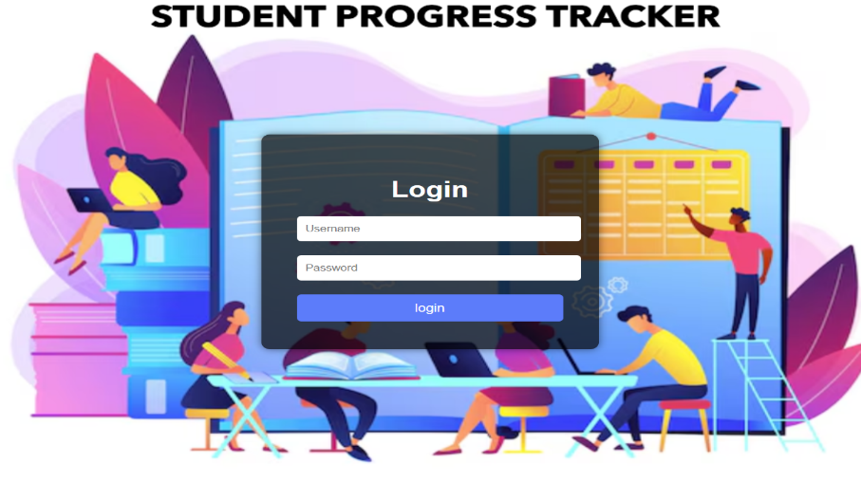**LOGIN PAGE:**

The above image shows the login page.It has fields username and password of the student ,as well as a login button.

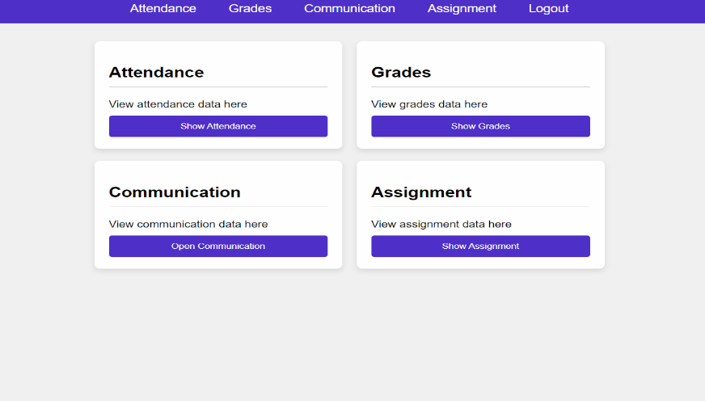**DASHBOARD:**

The above page is Dashboard page.It has four options in it they are Attendence,Grades,communication and Assignment.When you click on the buttons show Attendence,show grades,open communication and show assignment the respectively page is opened

13

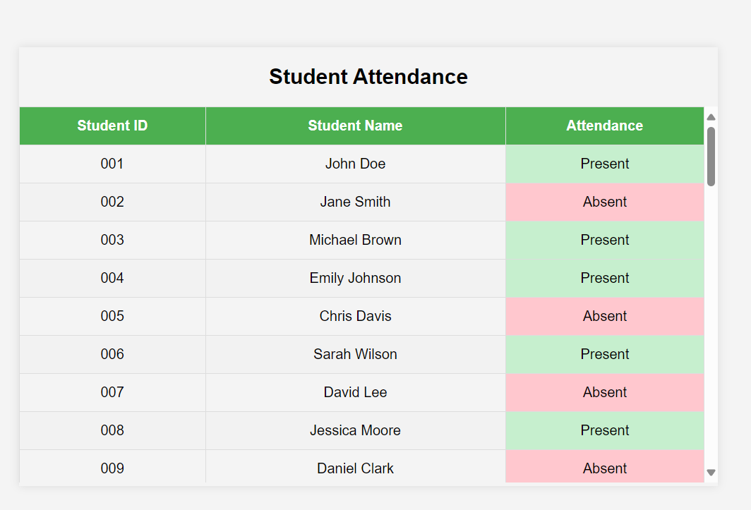**STUDENT ATTENDENCE :**

The above page is student attendance page in which we have three columns they are Student ID,Student

Name and attendance

1.Student ID: Displays the student ID’s.

2.Student Name:Displays Student Names.

3.Attendence:Shows whether the student is Present or Absent.

**STUDENT GRADES:**

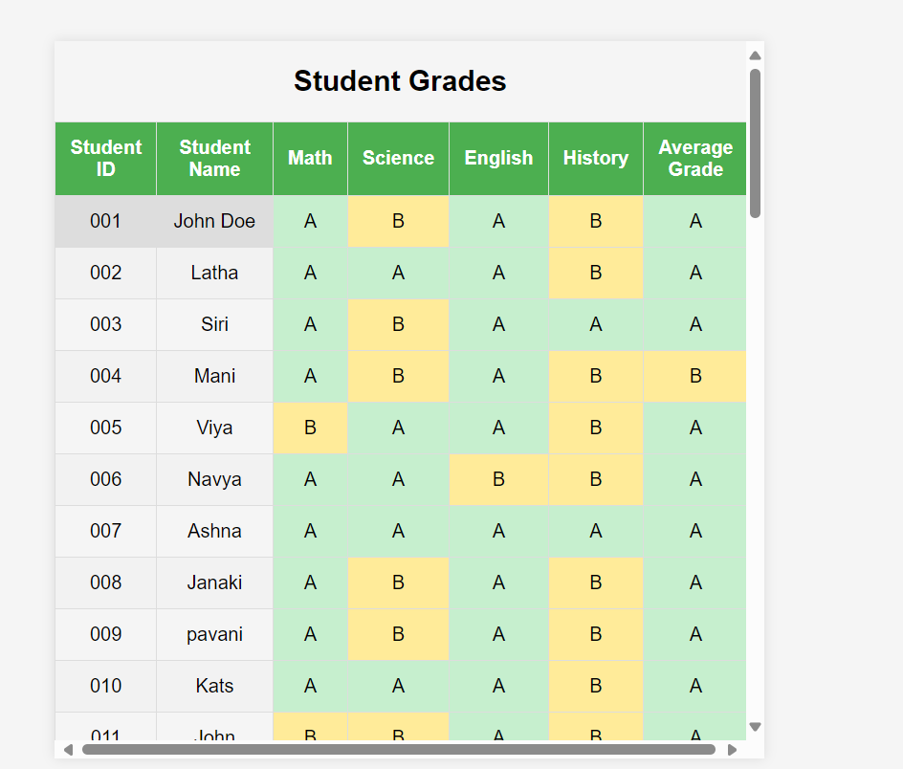

The above page is Student Grades page in which we have Student id column,Student Name column and different colums of different subjects .The Grades will be assigned as A,B,C,D according to their performances in the respective subject.

14

**COMMUNICATION PAGE:**

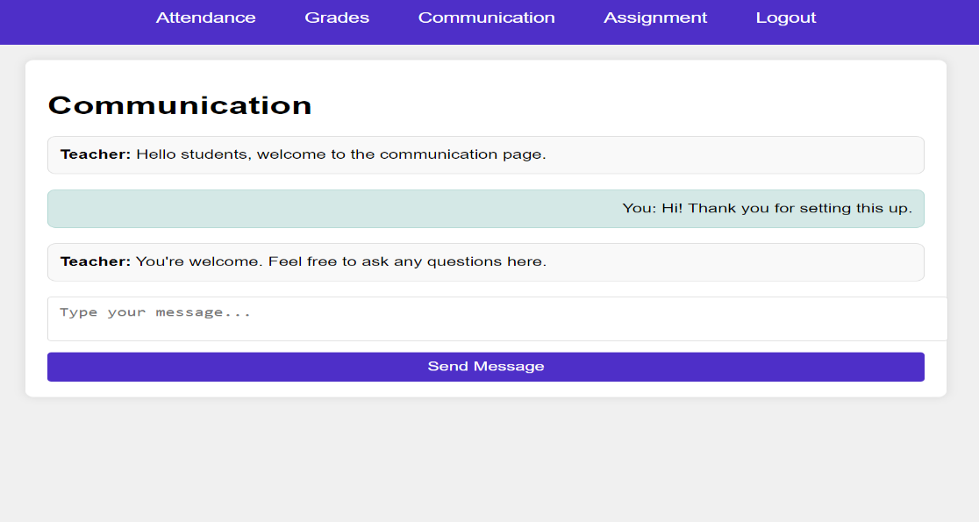

The above image shows the Communication page in which there will be interaction between a teacher and a student .In this page Student can ask their doubts and get the answers from the faculty.

**ASSIGNMENT PAGE:**

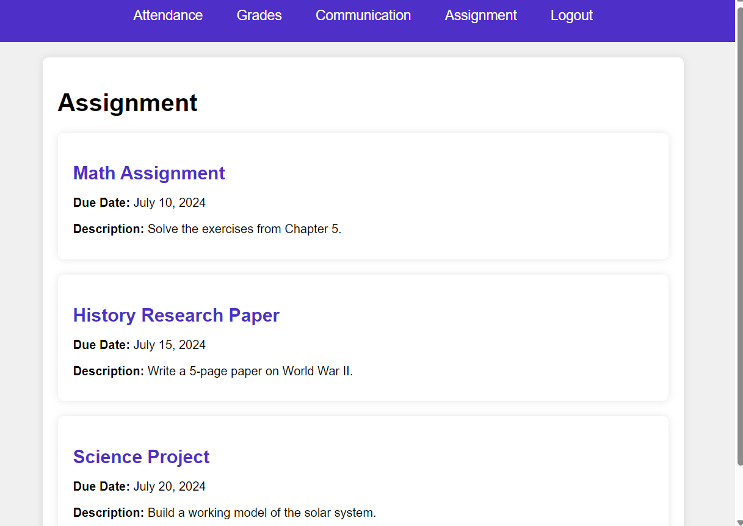

The above page is a Assignment page in which Student’s can see their assignments and due dates with some description below it .so,that they can get time to time updates and submit their Assignments on time.

15

**CHAPTER 7: FUTURE SCOPE**

**1)Data Analysis:**

**Progress Tracking**: Visualize student progress over time with easy-to-understand charts and graphs.

**2)Interactive Learning Content:**

**Dynamic Lessons**: Incorporate videos, simulations, and interactive quizzes directly into the tracker, making learning more engaging and effective.

**Learning Resources**: Provide links to additional resources and tutorials tailored to each student’s needs and interests.

**3)Career Path Guidance:**

**Future Planning**: Provide students with insights into how their current progress aligns with various career paths, helping them make informed decisions about their future.

**Skill Development**: Highlight skills that students excel in and suggest extracurricular activities or courses to further develop these talents.

**4)Enhanced Parent Engagement:**

**Parent Workshops**: Tools for virtual parent-teacher meetings and workshops can help parents support their children’s learning at home.

16

**CHAPTER 8: CONCLUSION**

Student Progress Trackers are set to transform the educational landscape by offering a personalized, engaging, and comprehensive approach to learning. These tools tailor education to each student's unique needs by analyzing their strengths and weaknesses, ensuring that they receive the right support at the right time. Real-time feedback allows teachers to quickly address areas of improvement and reinforce positive outcomes, making the learning process more effective.

Moreover, Student Progress Trackers significantly enhance parent engagement by providing easy access to their child's progress and facilitating communication with teachers. This keeps parents informed and involved in their child's education, enabling better support at home. Beyond academics, these tools also focus on the holistic development of students by monitoring wellbeing indicators such as mental health and stress levels, allowing for early intervention when necessary.

Future planning is another critical feature, helping students understand how their current performance aligns with potential career paths. By highlighting strengths and suggesting skill-development activities, these trackers guide students toward their future goals. Enhanced collaboration features foster a supportive learning community, encouraging teamwork and peer support through group projects and student forums.

Data-driven insights provided by detailed reports and analyses empower teachers to make informed decisions about their teaching strategies and identify trends in student performance. This ensures that educational methods can be adjusted to better meet student needs. Additionally, the accessibility and inclusivity of Student Progress Trackers make learning more equitable, accommodating students with disabilities and ensuring that all students can benefit from these tools.

In summary, Student Progress Trackers are poised to become indispensable in modern education, offering a personalized, data-driven, and holistic approach that benefits students, teachers, and parents alike. They promise to make education more effective, enjoyable, and inclusive, ultimately helping each student reach their full potential.

17

**CHAPTER 9: REFERENCES**

1.<https://ijrpr.com/uploads/V3ISSUE11/IJRPR8055.pdf>

2.https://ieeexplore.ieee.org/document/6418321

3. https://github.com/KunalSalunkhe12/Student-Progress-Tracker

4. https://www.jotform.com/blog/student-progress-tracking/

5. https://www.linkedin.com/pulse/student-progress-tracking-challenge-based-engagement-kim-flintoff

6. https://www.jotform.com/table-templates/student-progress-tracking-sheet

7. https://www.knack.com/blog/how-to-track-student-progress/

18